Integrating MuleESB With The Sphero Robotic Ball

Mule ESB can be integrated on cloud based applications like Sales force CRM, Mobile Applications etc, but that’s not thrilling! So we asked ourselves what’s thrilling? Integrating an intelligent Mule iPaaS ESB with the exciting [Sphero Robotic Ball](http://www.gosphero.com/discover/) through Salesforce is the mind bogglingly thrilling answer we came up with.

The programmable Sphero Robotic Ball is an interesting gadget. It can be programmed and controlled to change colors, positions, control speed, draw squares, turn circles etc.



**How did we do it?**

Equipped with the Sphero and a Sales Force account, we have created a mule workflow to create a lead in Salesforce (Fig 1.2) through an SMS and then trigger a message to Sphero changing its position and colors. Checkout our video: **YouTube Video**

Salesforce has been integrated with a MuleSoft [Salesforce Connector](http://www.mulesoft.org/connectors/salesforce-cloud-connector). Sphero is paired with a PC over Bluetooth. A dotnet client has been introduced to receive commands from Mule ESB and pass these commands to Sphero over Bluetooth. An intermediate database has been used to manage the state of the workflow and Mule Database Connector has been used to manage all the database operations.

Sphero WIN SDK API has been used to interact with Sphero Ball over Bluetooth. A Windows Store App with a web service client polls for the input commands through Mule and relays it to Sphero through the Sphero API.

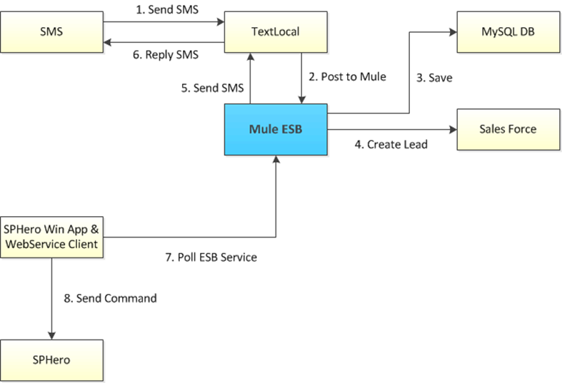

Fig 1.1 Integration Diagram

Here is the code snippet to create a new lead in Salesforce.

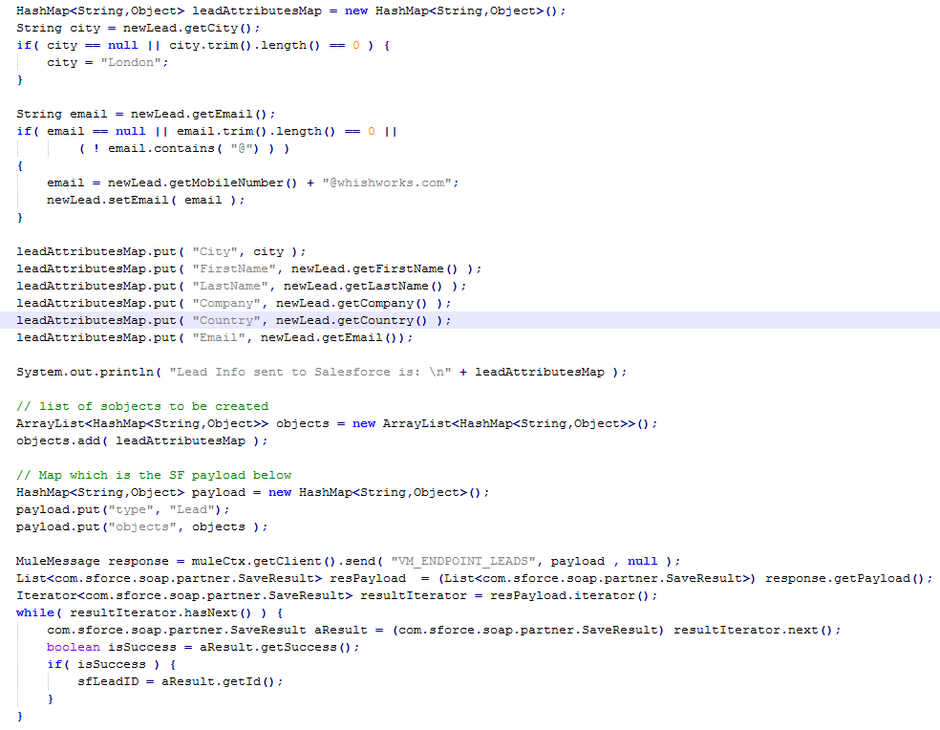

Fig 1.2 Code snippet

The source code of the demo is available at GITHUB - <https://github.com/WHISHWORKS>

With this integration through Mule ESB the response time is under a second and we are able to move Sphero at near real time. Call that mind bogglingly thrilling!

You can find more Mule related case studies from WHISHWORKS website.

<http://www.whishworks.com/index.php/consulting/technologies/mulesoft-esb>

**Mule ESB Sphero Integration: http://youtu.be/N_6sHGFVM4A via @youtube**